**Africa Center for project management**



**Name: Faith Ngoi Temu**

**Course: Certificate Course in Grants Management**

**Course Duration: Three months**

**Grants Management Final Exam**

**Thursday**

**March 07th; 2019**

**Answer all questions in this section**

1. Explain tips for grant seeking
2. **Do Extensive Research**

Find out which foundations or corporations are offering grants, and definitely look into whether or not there are any government grants that your organization can apply for. Once you figure out which grant you want to apply for, make sure you do a thorough job in researching the funding organization—know its background, its history, its philanthropic nature and what they’re looking for in a grantee. With those things in mind, you will get a better sense of what speaks to the funding organization because what’s important is not what your organization needs, but the ideas that are important to the funding organization.

1. **Be Concise and Thorough**

There are a number of components in a grant proposal, which can range from 10 to 20 pages long but it maybe even longer, depending on the project. A typical proposal will include:

* Introduction
* Mission Statement
* Needs Statement
* Goals and Objectives
* Impact Reporting
* Project Budget/Additional Funding

1. **Prove Your Nonprofit’s Sustainability**

A thriving nonprofit, a nonprofit that will spread ultimate change in the world, is a nonprofit that is sustainable—a nonprofit that will flourish for years to come. A grant is ultimately an investment, and funders will not just give them out to just any organization.

1. What are the major components of grant proposal?

The major components of a grant proposal are:

* **Introduction:** This includes the organization or Foundation background information.
* **Mission Statement:** is more than a couple of sentences; it guides decision-making, it gives the organization a sense of direction, it can announce your organizational values or ethical position and it can include the organization's Goals.
* **Needs Statement:** The purpose of a needs statement in a grant proposal is to present both facts and stories to support the needs for a project or program.
* **Goals and Objectives:** To more effectively "hook" grant reviewers, use visionary words in your goals. Try terms such as decrease, deliver, develop, establish, improve, increase, produce, and provide.
* **Impact Reporting:** 1) A clear description of the issue or problem that your research addresses 2) A statement of the action you are taking or intend to take to resolve the problem 3) An explanation of the impact 4) A list of the people involved in the research, other than yourself. Any collaborators, including institutions you are working with to complete the research, need to be listed in this section. And 5) Full contact of the team involved in the proposal writing.
* **Project Budget/Additional Funding:** These costs include expenditures for project personnel salaries and employee benefits, supplies, travel, equipment, telephones, and postage. All direct cost items must be included in the budget. Indirect costs are incurred by a grantee that cannot be identified specifically with a particular project or program.

1. Differentiate between grant and credit. Giving examples briefly discuss the two main categories of grants given out by co-operations and agencies.

The main difference between a grant and a loan is repayment. A loan requires you to repay the money you borrow, whereas a grant does not. Grants are, essentially, a gift. In other words, they’re non-repayable.

* **Greater opportunities:** When comparing grants vs. loans, loans offer more opportunities. There is a limited number of grants available. Loans, on the other hand, can be given by banks, private lenders, or individuals. This creates more opportunities to obtain the financing you need.
* **More financing available:** Grants are also limited in the amount of financing they can provide. In most cases, grant programs are sponsored by government departments and only a certain amount of funding is available each year. With a loan, you can obtain as much financing as your credit and ability to repay will allow.
* **No repayment necessary:** Grants are non-repayable. Once you’re awarded the grant money, it’s yours without any strings attached. There’s no need to worry about monthly payments or piling on more debt. Repayment is the fundamental difference between a grant and a loan, and also what makes grants more valuable than loans.
* **No risk:** Grants are a no-risk way to obtain the financing you need. If a loan is not repaid, you put your credit rating and assets in jeopardy. Grants do not require repayment and will only benefit you or your business.

The two categories of grants given by co-operation and agencies are:

* **Block grants:** Money given for a fairly broad purpose with few strings attached.
* **Categorical grants:** Money given for a specific purpose that comes with restrictions concerning how the money should be spent. There are two types of categorical grants:

1. Discuss the role of government in grant mobilization.

Resource mobilization is actually a process of raising different types of support for Government programs/organization goals. As said above, it can include both cash and in-kind support. Volunteer support where volunteers provide their time and resources to support the work of your organization.

The main role of government in grant mobilization is to make sure it gives full support to the donors and advocate for the intended goals to be achieved by the donor funds.

It is also their role as a government to make sure the resources mobilized by NGO’s and Organization are used for the purpose intended and not otherwise, unless there is an official amendment that has be agreed by both parties.

Advocating for resource mobilization and convene meetings with stakeholders and potential funders is also one of the main roles of the government in grants mobilization and a much appreciated one as it shows that; the government is aware of the needs and is there to support stakeholders in addressing these needs.

1. For any successful grant, budget cycle plays a significant role. Using a diagram explain the budget cycle.

[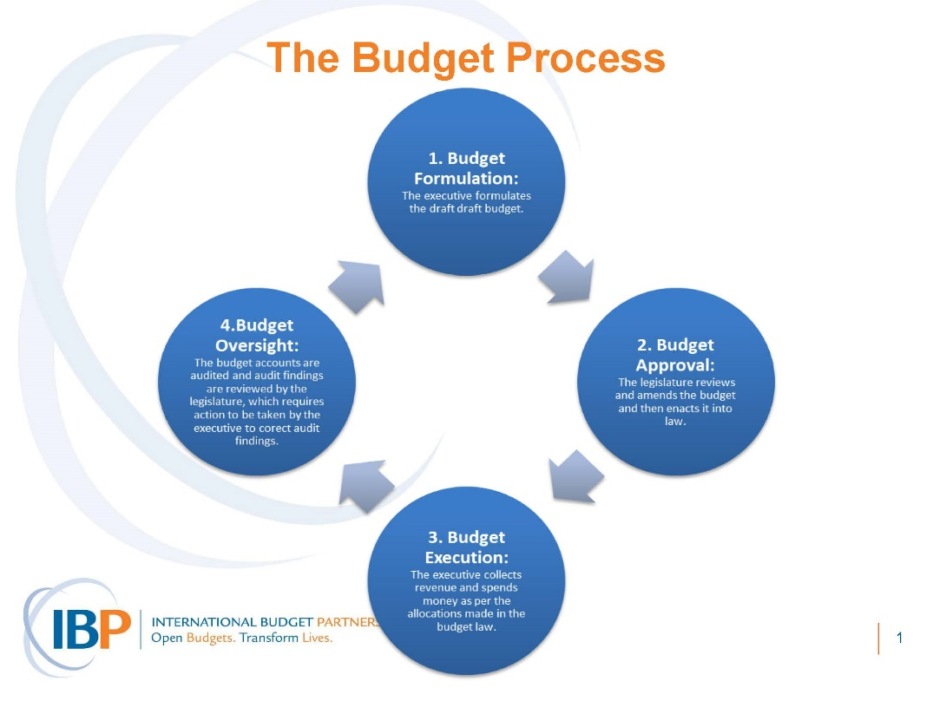](https://www.google.com/url?sa=i&rct=j&q=&esrc=s&source=images&cd=&cad=rja&uact=8&ved=2ahUKEwj8nc_B4O_gAhWqxoUKHU1SBpcQjRx6BAgBEAU&url=https%3A%2F%2Fwww.internationalbudget.org%2Fcapacity-building%2Fcapacity-building-materials%2Fhealth-budgets%2F&psig=AOvVaw2Qulx7x_6FOciGJC0D19vF&ust=1552038597358363)

1. Analyze the type of costs incurred in budgeting of grants

**Operational Costs**: Operational costs include those expenses that have to be met for implementing activities for a project or an [organization](https://www2.fundsforngos.org/tag/organisations/). These are directly billed to the donor agency because they have a direct impact on the beneficiary community

**Staff costs**: Staff costs refer to the expenses towards paying salaries and consultancy fee to the staff of the organization. Staff costs include expenses right from the recruitment of the staff (interview, orientation) to their salaries.

**Core Costs**: Core costs are also costs incurred towards the operational expenses but of the organization. Most donor agencies would like to know how much money the NGO will spend on the administration of the organization.

**Capital Costs**: Although donor agencies are advising [NGOs](https://www2.fundsforngos.org/tag/ngos/) to massively cut down on capital costs, yet these costs continue to remain essential. These include expenses for buying computers, office furniture, vehicles, office building etc.

1. What is the importance of involving a financial sustainability committee?

**Financial Sustainability Committee:** Is a group that helps you raise money or obtain goods for your project. Generally, such a group is made up of people in your community that have, or can get money or goods. People who have experience dealing with legal or financial issues, such as lawyers and accountants, may also be members. That's because they can help you with the many legal issues that can affect you financially, such as becoming tax exempt.

The followings are the importance of involving a financial Sustainability Committee

* **Help get resources to help your organization survive** - and thrive
* **Ease the transition from one source of funding to another**, such as at the end of a grant period
* **Help find money or goods from many different sources** - a financial committee that has members with many connections will help lead to a diverse funding base for your organization, which is one of the most effective ways to ensure sustainability.
* **Meet some funders' requirements** - sometimes, the existence of a committee for financial sustainability is a requirement for receiving a grant.
* A**llow members of your group to focus their time and energy on the jobs they were hired for**. Too often, members of organization spend so much time trying to find resources for the organization they are unable to spend time doing what they were hired to do. A community mobilizer may spend all of his time mobilizing the community around the need for money to keep the organization going, instead of the real issue of child hunger. for example. By having a committee of experts taking care of the finances, you allow the mobilizer to do what he knows best, not something he (potentially) knows little about.

1. Why is internal controls important to an organization?

**Internal controls**: are the mechanisms, rules, and procedures implemented by a company to ensure the integrity of financial and accounting information, promote accountability and prevent fraud. Besides complying with laws and regulations, and preventing employees from stealing assets or committing fraud, internal controls can help improve operational efficiency by improving the accuracy and timeliness of [financial reporting](https://www.investopedia.com/university/accounting/accounting6.asp).

It helps management monitor the effectiveness of the controls in an ever-changing environment. Internal controls are critical in the process of setting and achieving operational, strategic, compliance and reporting objectives. Risk management identifies threats to the organization, while internal controls are designed to provide reasonable assurance regarding the achievement of operational objectives, such as the effectiveness and efficiency of operations, accurate and reliable financial reports, and compliance with applicable laws and regulations.

1. Discuss some factors that lead to disqualification of applied grant.
   1. **Not allowing sufficient time to write:** Allowing enough time to do the research, effectively writing the proposal, and ensuring that all the letters of recommendation and forms requested are appropriately completed are key components to success. It has been demonstrated that those who submit their proposals three or more days prior to the deadline have a 37% greater chance of getting funded than those who submit at the last minute.
   2. **Not paying attention to instructions:** It is extremely frustrating to be rejected for something as simple as margin width or font size, yet this is a common occurrence. 50% of the proposals that are submitted to various federal agencies are immediately eliminated because directions were not followed.
   3. **Poor writing:** Grammatical errors are not the only sign of poor writing. There are many more, such as the use of acronyms and jargon, wordy sentences, long paragraphs, and making readers fish for the main reason the request is being made.
   4. **Failure to edit the application:** This problem can easily be remedied if a prospective grantee gives his/her proposal to a [qualified editor](https://granttrainingcenter.com/proposal_review) to proofread before submission. Although reviewers are not charged to score an application for grammar, poor writing reflects sloppy work and lack of attention to detail.
   5. **Failure to convey to the reviewers that your research is interesting:** The Principal Investigator (PI) should be enthusiastic about the project. Lack of enthusiasm is contagious; reviewers will feel it and will lose interest in your project.
   6. **Lack of preliminary data or research:** If you are writing a research grant, preliminary data is essential in proving that your hunch or hypothesis is plausible. If you are writing a project grant, thorough research of your subject matter is what makes your proposal credible.
   7. **Project that is too ambitious:** Lack of focus is clearly reflected both in the scope, as well as the writing. Your preliminary data and research will be a good guide for how to narrow the focus of your proposal and do what is possible within the allotted time. Another good restrictive measurement is the budget.
   8. **Lack of experience in the field:** The credibility of your proposal depends on those who will implement it. Thus, you must include the most qualified personnel. Reviewers are looking for project directors or principal investigators who are trained in their field, have succeeded with similar projects in the past, are recognized for their contributions, and have a proven record of efficiently [working in a team](https://granttrainingcenter.com/membership_description).
   9. **Selecting a project that will have limited impact:** A project that will have broad impact demonstrates that the money awarded will serve a large population that needs the intervention. Limited impact on the other hand, can be costly, not sustainable, and restricted to a small population.
   10. **Limited support from your institution:** Institutional support demonstrates that your project is part of the institutional mission, and that it will be sustained in the future. Furthermore, projects that your institution financially and philosophically supports have a much greater chance of success.

Many of the aforementioned mistakes can easily be committed if you are in a rush. Knowing who you are, what you wish to accomplish, and delineating how you will accomplish your tasks is extremely important. Ultimately, professionalism, attention to detail, and enthusiasm will be the characteristics that will advance your proposal to the top of the competition.

1. what is the importance of a money management plan?

Since budgeting allows you to create a spending plan for your money, it ensures that you will always have enough money for the things you need and the things that are important to you. Following a budget or spending plan will also keep you out of debt or help you work your way out of debt if you are currently in debt.

The importance of a money management plan is to;

**Have Better Financial Security**

Being a good money manager allows you to accumulate savings. This gives you the security of knowing that you have the resources to deal with unexpected expenses – such things as the car breaking down, your dog destroying your new sofa while you were at work or your boss politely suggesting you should seek employment elsewhere. If you reviewed your expenditures for an entire year, you would see that unexpected expenses inevitably occur. Having savings available means you don’t have to use credit cards to pay for emergencies.

**Take Advantage of Opportunities**

From time to time, we all encounter opportunities to make more money or have an interesting experience. A friend may alert you to an investment opportunity, or you may find a terrific deal on a once-in-a-lifetime vacation. It’s frustrating to not have the cash available to take advantage of these opportunities. People who have been successful at managing their money get to go to exciting events like the Masters Golf Tournament, while those who have mismanaged their money stay home and play miniature golf with their somewhat annoying relatives.

**Pay Lower Interest Rates**

Your credit score is one measure of your money-management skill. A high score means you have paid your bills on time and kept your total debt level relatively low. Achieving a high score has rewards that can help you keep more of what you earn because you will be charged lower interest rates for home mortgages, credit cards and auto loans – even insurance on your car. And, of course, you can brag about your high score at parties.

**Reduce Stress and Conflict**

Not being able to pay your bills by the due date, or finding you are always breaking at some time during the month can lead to significant amounts of stress for a couple, resulting in conflict over financial objectives and spending habits. A 2017 study from the American Psychological Association found that 62 percent of Americans are stressed about money. That stress can lead to health problems, experts say, including migraines, cardiovascular disease and insomnia. Learning how to manage your finances so you have a surplus of funds can relieve this pressure and allow you to enjoy life with your partner rather than being in a constant state of worry about the future.

**Earn More Money**

As your incomes grow, your financial planning will not just involve budgeting so that all the expenses are covered each month, but also determining how to invest the surplus that accumulates above what you spend. Becoming knowledgeable about investment vehicles such as stocks and mutual funds can allow you to earn more on your investment funds than you could by leaving them in a savings account at the bank. Bear in mind that dog tracks or offshore casinos are not generally recognized as sound investment vehicles. The great thing about having investments is that while you are at work earning money, your investments are also working for you.